IV. ANALYSING TWEETS AND COMMUNITY SUPPORT

The word clouds generated are depicted in this section. Following are the figures and their description:

Figure 4.1 shows the worldcloud for all the hashtags retreived from the tweets. As depicted, words in bigger font such as ‘zika’ and ‘rio2016’ are the most frequent hashtags.

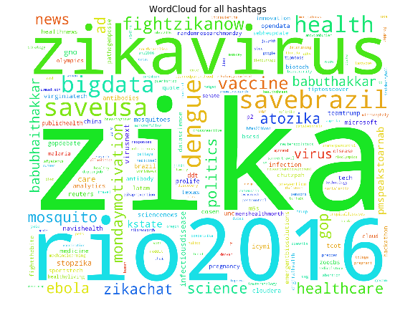

*Figure 4.1*

The wordcloud in Figure 4.2 is related to the twitter accounts which have tweeted related to Zika most frequently.

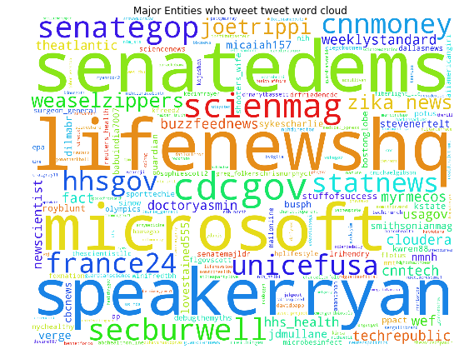

*Figure 4.2*

Word clouds were also generated for the 3 classes :

1. Figure 4.3.1 for class ‘fight and prevention’
2. Figure 4.3.2 for class ‘cure’
3. Figure 4.3.3 for class ‘infected and death’

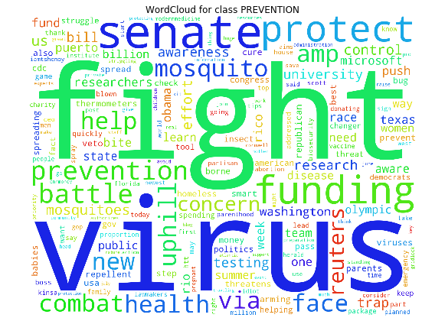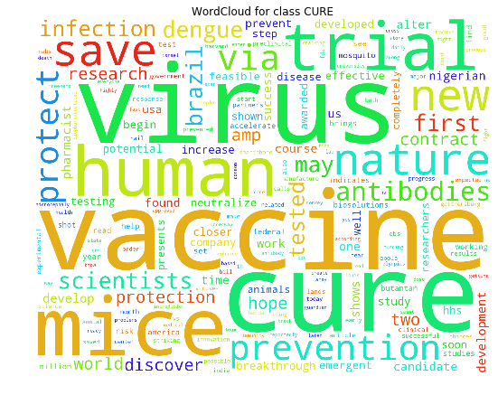

*Figure 4.3.1*  *Figure 4.3.2*

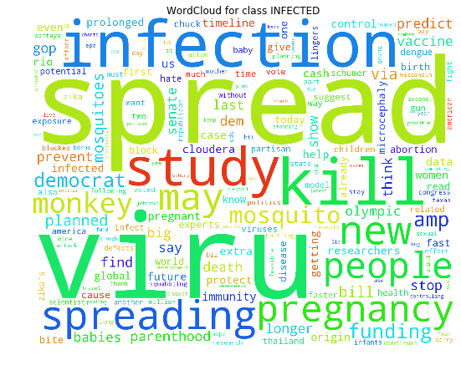

*Figure 4.3.3*